“非饱和土力学前沿科学问题”国际讲习班通知
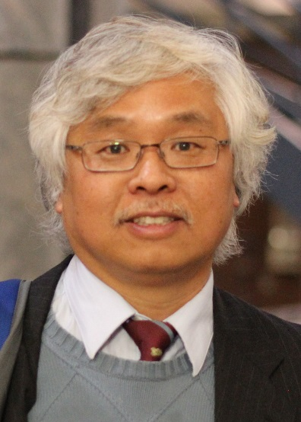
受信阳师范学院国际人才合作项目资助，应信阳师范学院建筑与土木工程学院邀请，美国科罗拉多矿业大学土木与环境工程系Ning Lu (卢宁)教授将于2017年3月25日到我校访问，并做 “非饱和土力学前沿科学问题”讲座，讲习班日程安排如下。
欢迎感兴趣的同行、学者与研究生参加！

第一讲: Soil water retention mechanisms and its relations to specific surface area and cation exchange capacity
时间：March 26 14:30 pm -16:00 pm 地点：建筑与土木工程学院会议室 (综合实验楼206室)

第二讲: Generalized soil water retention curve
时间：March 26 16:30 pm – 17:30 pm 地点：建筑与土木工程学院会议室 (综合实验楼206室)

第三讲: Soil shrinkage curve and its relations to specific surface area and cation exchange capacity
时间：March 27 08:30 am - 10:00 am 地点：建筑与土木工程学院会议室 (综合实验楼206室)

第四讲: Soil self-consolidation behavior
时间：March 27 10:30 am – 11:30 am地点：建筑与土木工程学院会议室 (综合实验楼206室)

第五讲: 2017 Ralph B. Peck Lecture 本次讲习班主题报告
第一部分: Introducing American University System through Colorado School of Mines
“美国大学系统简介-从科罗拉多矿业大学的视角”
第二部分: A New Paradigm for Slope Stability Analysis under Variably Saturated Conditions
“变饱和状态下边坡稳定分析的新范式”，为3月13日卢宁教授在美国土木工程师学会岩土年会（Geotechnical Frontiers 2017）上为Ralph B. Peck Lecture所做的60分钟报告
时间：March 27 15:00 pm -17:00 pm 地点：信阳师范学院图书馆 贤林讲坛

第六讲: Elastic modulus function of unsaturated soils
时间：March 28 09:00 am – 10:30 am 地点：建筑与土木工程学院会议室 (综合实验楼206室)

联系人：周葆春，zhoubc@xynu.edu.cn；马全国，mqgxynu@163.com，13723124820
A New Paradigm for Slope Stability Analysis under Variably Saturated Conditions
摘要 This lecture will highlight two major advancements in slope stability analysis that stemmed from several multi-year field hydro-mechanical monitoring. The first significant breakthrough is the capability to handle the transient field of effective stress in variably saturated slopes under rainfall conditions. Using effective stress analysis preserves the rigor, simplicity, and practicality of the classical slope stability methodologies (e.g., limit equilibrium). The second is to quantify the field of local factor of safety (FS), which radically departs from the classical one-FS-for-one-slope paradigm and allows identification of failure initiation and progression zones in slopes. The new hydro-mechanical framework for slope stability design and analysis only requires three parameters in addition to the classical shear strength and seepage parameters. These parameters are used to uniquely define slope materials’ constitutive relations of the soil water characteristic curve, hydraulic conductivity function, and suction stress characteristic curve. Several field cases are used to illustrate the validity, accuracy and simplicity of the new hydro-mechanical framework for slope stability analysis.

讲座者简历Ning Lu is professor of civil and environmental engineering at Colorado School of Mines (CSM) and the director of the joint CSM/US Geological Survey Geotechnical Research Laboratory in Golden, CO. He is a recipient of the ASCE 2007 Norman Medal, of the ASCE 2010 Croes Medal, and of the ASCE 2017 Ralph B. Peck Award, as well as a fellow of ASCE, Engineering Mechanics Institute, and Geological Society of America. His primary research interests are flow and stress laws in multiphase porous media, rainfall-induced instability of natural and engineered slopes, geologic hazards, energy storage in porous media, and subsurface nuclear waste isolation. He is the senior author of the widely used textbook Unsaturated Soil Mechanics (John Wiley and Sons, 2004) and the recently published textbook Hillslope Hydrology and Stability (Cambridge University Press, 2013).

中文简介
卢宁(Ning Lu)，国际著名的土力学与水力学专家。
1991年毕业于美国约翰.霍普金斯大学获土木工程博士学位，现任美国科罗拉多矿业大学(2016年US News美国最佳大学排名75)土木与环境工程系终身正教授(Full Professor)，美国国家地质调查局—科罗拉多矿业大学岩土工程联合实验室主任，高科技公司Soil Water Retention, LLC总裁(President)。
卢宁教授是美国土木工程师学会(ASCE)最高奖章Normal Medal(2007)和J. James Croes Medal(2010)、Ralph B. Peck Award(2017)的获得者。
卢宁教授主要学术兼职有：美国土木工程师学会(ASCE)会士(fellow)、美国地质学会会士(fellow)，美国土木工程师学会工程力学分会(ASCE’s Engineering Mechanics Institute)会士(fellow)；国际著名SCI期刊Vadose Zone Hydrology, Geotechnical Testing Journal的副主编(associate editor)。
卢宁教授的主要研究兴趣为非饱和土的力学与水力学行为、降雨导致的自然边坡与工程边坡失稳、地质灾害、多孔介质中的能量储存(地热开发与储存)、核废料地下处置。
卢宁教授是10个美国国家自然科学基金项目(NSF)的主持人(PI)，109篇Peer-Reviewed Journal Articles的主要作者，Google Scholar统计总引用次数4011，h-index为29。
卢宁教授撰写的著作《非饱和土力学》(美国John Wiley & Sons，2004)和《斜坡水文与稳定》(英国Cambridge University Press，2013)在国际上获得广泛好评，其中译本均在中国高等教育出版社出版。

